1. GitHub Repo Link
https://github.com/Izumoff/uncw-lost-and-found

2. Preliminary Feature List
Actor | Feature | Priority
Campus Community User | Log in | Critical
Campus Community User | Log out | Critical
Campus Community User | Create Lost Item report with required details | Critical
Campus Community User | Can see the status of each of their reports | Critical
Campus Community User | View own reports | Critical
Security Office Staff | Review reports submitted by campus community users | Critical
Security Office Staff | Approve or reject reports for publication | Critical
Security Office Staff | Log in | Critical
Security Office Staff | Log out | Critical

3. User Stories and Acceptance Criteria
User Story | Acceptance Criteria | Status
As a campus community user, I want to log in/log out of the lost & found website so that my account and reports are secure so I can manage them | - When the campus community user visits the static website, they see a login page with a username/password field & a login button  - When they enter the valid credentials, they are taken to the website  - When they enter invalid credentials, a message appears informing the user that the credentials are incorrect  - When a logged-in user clicks logout, they are returned, to the login page, and can no longer have access to the desired tools  - When a user tries to visit a page that requires login without being logged in first, they are automatically sent to the login page. | Critical
As a security office staff, I can review any report submitted by the campus community user so that the directory reflects whether an item is lost or found accurately and to ensure that users can see only active and relevant reports. | - When a security office staff logs into the website, they can see all the listed reports under the staff dashboard  - When a security office staff views the reports, they have the option to change the status of the report to open, under review, or resolved  - When the report’s status changes, the page updates to reflect the new status  - When the security staff clicks “close report” on any report listing, the report is removed from the public listing  - Campus community users cannot see the status controls | Critical

4. Estimated Story Points
ID | Actor | Feature | Story Point
US-01 | Campus Community User | Log in | 3
US-02 | Campus Community User | Log out | 3
US-03 | Campus Community User | Create Lost Item report with required details | 8
US-04 | Campus Community User | Can see the status of each of their reports | 5
US-05 | Campus Community User | View own reports | 5
US-06 | Security Office Staff | Review reports submitted by campus community users | 5
US-07 | Security Office Staff | Approve or reject reports for publication | 3
US-08 | Security Office Staff | Log in | 3
US-09 | Security Office Staff | Log out | 3

5. User Interface Design
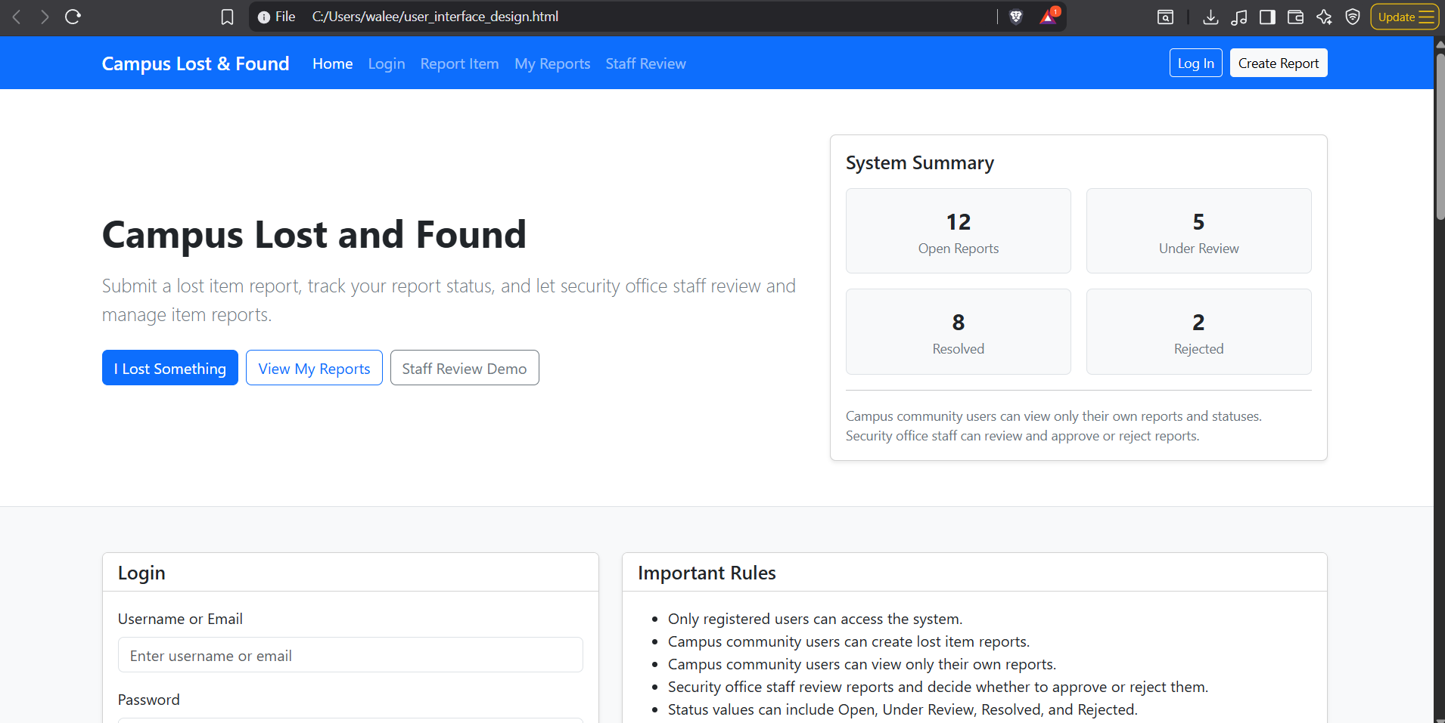
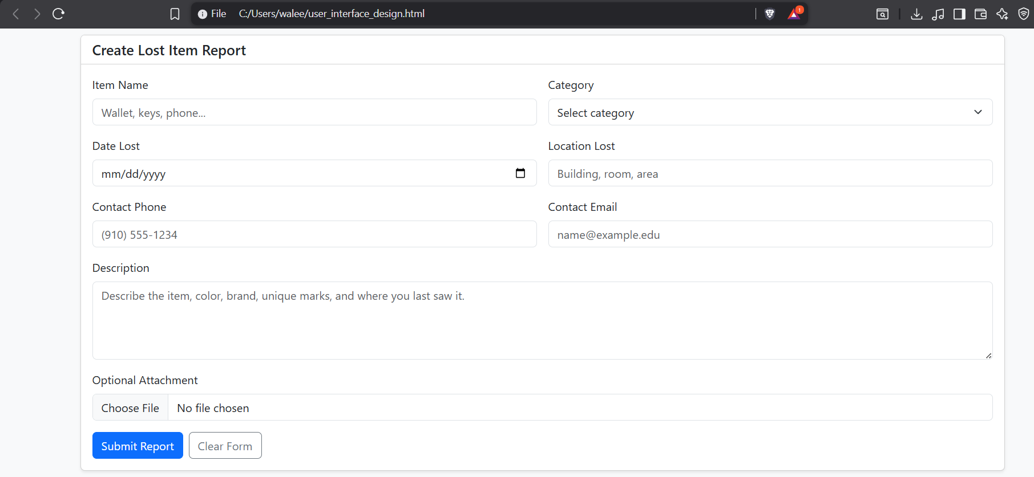
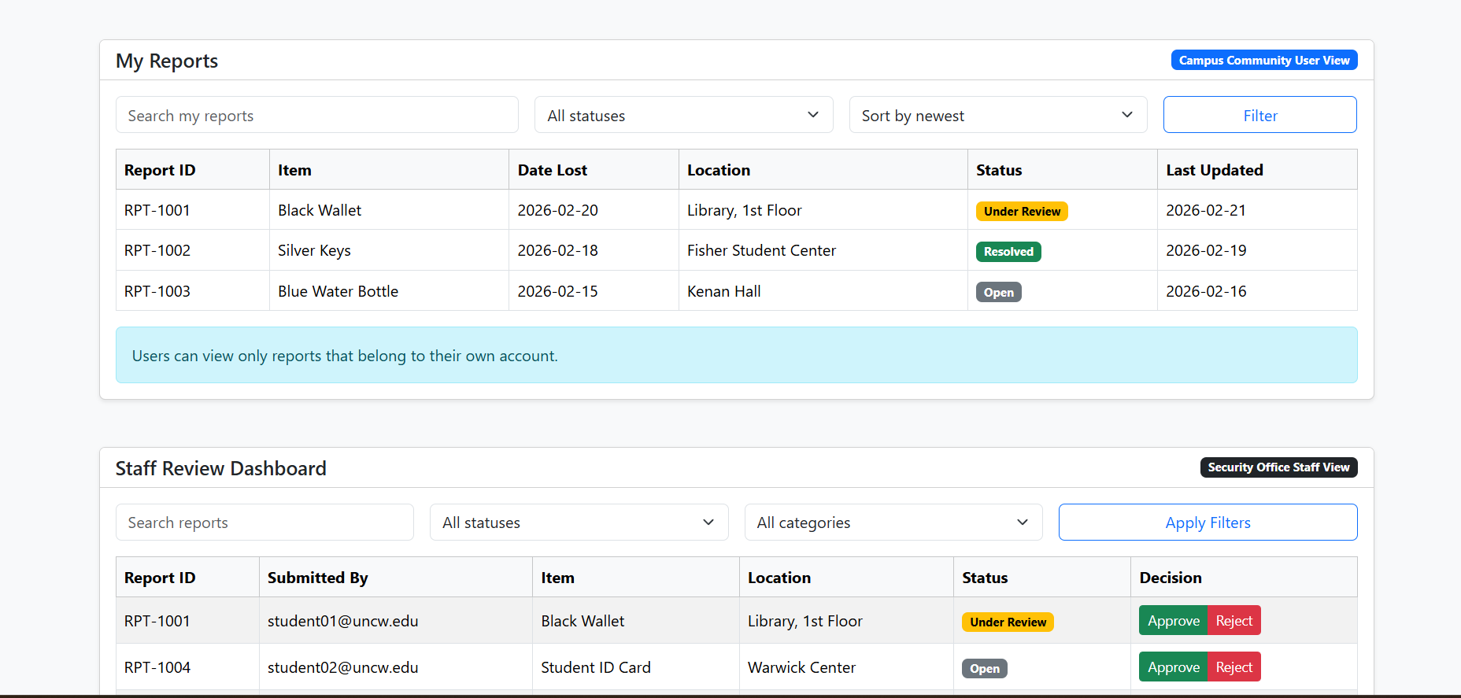

5. User Case Diagram
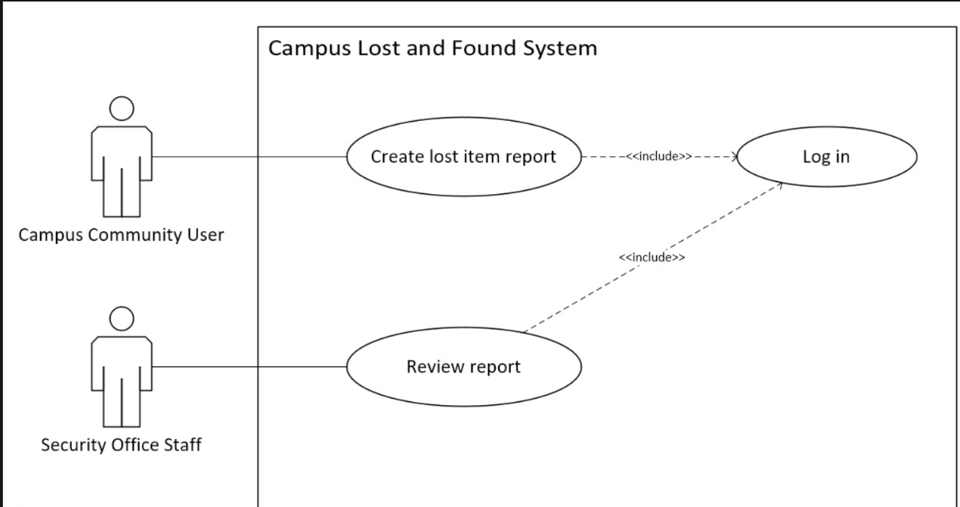

6. Draft of Architectural Design and Module Design

Architectural Design:
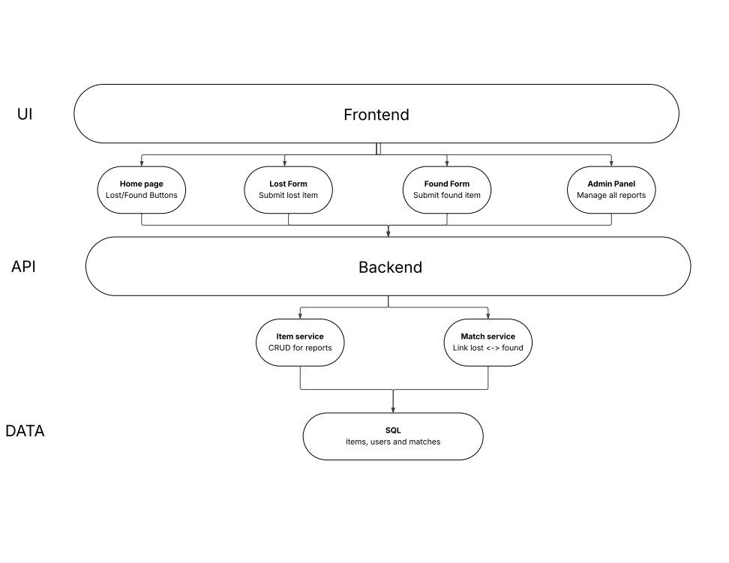

Module Design:
